# 

**Chapter 1 Introduction Not Important** **3**

Material Types 3

What is MSE? 5

**Chapter 2 Atomic Structure and Interatomic Bonding** **7**

Atoms 7

Electron configurations 7

Electron practice problem 9

Bonding types 9

Attraction energy 10

Summary 11

**Chapter 3 The Structure of Crystalline Solids** **12**

Atomic Structure Basics 12

Unit Cells and Densities 15

**Chapter 12 Structures and Properties of Ceramics** **19**

Theoretical ceramic density 21

**Chapter 4 Imperfections in Solids** **22**

Vacancy Equation 22

Nv=N exp(-QvkT) 22

Composition/Concentration 24

Dislocations 24

**Chapter 5 Diffusion** **27**

Interdiffusion zone (L) 28

Fick’s first law 29

Fick’s second law 29

concentration at point x is Cx 30

Factors that influence diffusion 31

**Chapter 6 Mechanical Properties** **31**

Stress and Strain 31

Poisson's ratio 32

Shear loading 32

Ductility 32

Resilience 33

Brinell Hardness test 34

**Exam:** **34**

**Chapter 7 Dislocations and Strength Mechanics** **35**

Slip plane notation 35

Mechanisms of strengthening(hardening) of metals 36

Hall-Petch equations 36

Recrystallization 36

**Chapter 8 Failure** **37**

Crack types 37

Orocoan theory of brittle fracture 37

Critical stress for crack propagation 38

Fracture toughness: how strong and ductile 38

Fatigue 39

Creep strain/deformation 40

**Chapter 9 Phase Diagrams** **42**

Reading phase diagrams 44

Microstructural development 46

Iron-Carbon System 47

**Chapter 10 Phase Transformations** **50**

Phase transformations 50

Thermal Processing of Steel 50

**Final Review** **55**

# 

# Chapter 1 Introduction Not Important

## Material Types

* + What are materials?
    - The things something is made of
  + What is a materials composition?
    - Chemical makeup of a material
  + What are materials properties?
    - How a material functions
      * Mechanical Properties
      * Physical properties
  + Can materials have the same composition but different properties?
    - YES!!!
    - Like carbon: graphite vs diamonds vs solution
    - Study how we can start with the same composition but different properties
    - How is this possible?
      * Material structure
        + Arrangement of atoms and ions in material
  + Primary material classifications
    - Metals
      * Conductive solids with metallic bonds
      * What we do with them
        + Casting
        + Heating
      * Applications
        + Medical implants
        + Infrastructure
        + Super alloys
    - Ceramics
      * Inorganic and nonmetallic
        + Ionic bonds
      * Examples
        + Gemstones
        + Stained glass
        + High end cutlery
        + Thermal applications
    - Polymers
      * Plastics, synthetics
      * Applications
        + Drug delivery
        + Hydrophobic coatings
        + Mechanical applications

Bulletproof vest

* + - * + Membranes

Selective diffusion of certain molecules

* + - Composites
      * Combining 2 or more of the above listed materials
      * Matrix reinforcements
      * Increased properties
  + Advanced materials
    - Semiconductors
      * Properties between metallic and ceramic materials
    - Biomaterials
      * Biocompatible materials
      * Mimic or augment biological properties
    - Smart Materials
      * Shape memory alloys
      * Piezoelectric materials
    - Nanomaterials
      * Characterized by the size
        + x10-9 m
  + Materials Properties
    - Mechanical
      * Strength of a material
      * 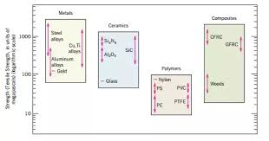
    - Electrical
      * 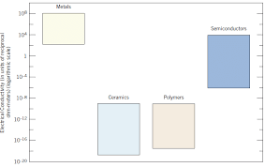
      * Semiconductors fill gap between metals and polymers
      * Electrical properties change with temperature
    - Thermal
      * Insulation properties
    - Magnetic
      * Magnitiation ability
      * Strength of field
      * BH curve
    - Optical
      * Porosity
        + Changes how see-through something is
    - Deteriorative
      * Corrosion performance
      * Crack propagation
  + Key points of the lecture
    - 3 main classification
      * Metals
      * Ceramics
      * Polymers
    - Composites are a combination
    - 4 advanced materials
      * Semiconductors
      * Biomaterials
      * Smart materials
      * Nanomaterials
    - Classifications can be based on
      * Composition
      * Bondy type
      * Size
      * Properties

## What is MSE?

* + What is Materials Science and Engineering
    - Structure
      * How atoms and things are arranged
      * Different scale
        + Nano: Atoms
        + Micro: Grains
        + Macro: Welds
    - Properties
      * Thermal
        + How thermally conductive
      * Mechanical
        + Strength
      * Magnetic
      * Electrical
    - Processing
      * How something is made
        + Cast
        + Joined
        + Additive manufacturing

3D printable

* + - Performance
      * How well it does its job
    - These are all interrelated to each other
      * 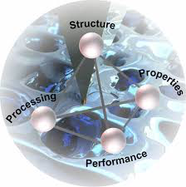
  + Why study MSE
    - It is everything, how we understand the materials around us
    - How to select the most optimal material
    - Create new materials
    - Develop new processing methods
    - Create new applications
  + Material Science
    - Basic knowledge of materials
  + Material engineering
    - Applied knowledge of materials
  + Case study - Material selection
    - Problem: Select a suitable material for a bicycle frame
      * We want:
        + Low cost
        + Low density
        + High strength
        + Easy shapeability

For manufacturing

* + - * + High Degradation resistance
      * Carbon fiber reinforced plastic checks every mark accept for cost
  + Key point
    - MSE is structure-Processing-Property-Performance relationships for materials

# Chapter 2 Atomic Structure and Interatomic Bonding

## Atoms

* + Proton
    - Mass: 1.67x10-24
    - Charge: 1.602x10-19 C
  + Neutron
    - Mass: 1.68x10-24
  + Electron
    - 9.11x10-24
    - Charge: -1.602x10-19 C
  + Periodic Table of the Elements
    - Atomic number (Z)
      * Unique to each element
    - Symbol
      * Letters that represent it
    - Atomic weight/Atomic mass/AMU
      * All the same
      * g/mol
    - Mol: 6.022x1023

## Electron configurations

* + Electrons obey the laws of quantum mechanics
  + Electrons define the way atoms react with their environment
  + Described by their energy state
    - Orbitals
      * Specific energy levels
    - Adding energy to an e move it to a higher energy level
    - When an electron lowers down, it releases energy
      * Usually in the form of a photon
    - If we give enough energy, we can completely eject an electron
      * Photoelectric
    - ∆E = $\frac{hc}{λ}$ =h $ν$
      * h = Planck's Constant = 6.63x10-34
      * c = speed of light = 3x108
      * = Wavelength of light (m)
      * $ν$ = frequency of light (Hz)
  + Quantum numbers of electrons of atoms
    - Principal quantum number (n)
      * Represent main energy levels
      * Range 1 to 7
        + Closest to furthest from the nucleus
      * Larger the ‘n’, the higher the energy
    - Subsidiary quantum number (l)
      * Represents sub energy levels (orbitals)
      * Range 0...n-1
      * Represented by s,p,d,f
  + Energy in a hydrogen atom
    - Hydrogen atom has one proton and one electron
      * Electron is naturally in n=1
        + Ground state
      * Energy of hydrogen for given energy levels is

$E=-\frac{13.6}{n^{2}}eV$

eV is electron Volts

* + - * + Ionization energy

Energy to completely remove the electron

13.6 eV

* + Electron structure of multielectron atom
    - Maximum number of electrons in each shell is 2n2
    - Size of the atom is determined by electrons
    - Electron configuration list the arrangement of electrons in orbitals
  + Valence
    - Number of electrons that participate in bonding and chemical reactions
    - Outermost electrons
      * Typically outer s and p energy levels
  + Electronic structure and chemical activity
    - Depending on the reactivity of the outermost electrons
    - Electropositive
      * Metallic
      * Gives electrons
        + Ends up with more positive charge

Cations

* + - * Positive oxidation number
        + Number of electrons we can give away
        + 1A and 2A on the periodic table
    - Electronegative
      * Non-metallic
      * Accept electrons in reaction
      * Negative oxidation number
        + 6A and 7A on the periodic table
      * anions
    - Electronegativity
      * The degree to which atoms attract electrons

## Electron practice problem

* + If an electron undergoes transition from n=3 state to n=2 state,
    - The energy of photon emitted is
      * Use $E=-\frac{13.6}{n^{2}}eV$
      * 1.89 eV
      * 1.89 * 1.60x10-19J = 3.02x10-19 J
    - The frequency of the released photon
      * ∆E=h $ν$
      * 3.02x10-19 J = h
      * = 4.55x1014 Hz
    - The wavelength of the photon
      * c = $λν$
      * $λ$ = 6.59x10-7 m

## Bonding types

* + Primary bonding
    - Ionic
      * Atom transfers one or more valence electrons to another atom
        + Atoms become charged and the charges attract the two atoms
      * Occurs between metals and nonmetals
    - Covalent
      * Atoms share one or more valence electrons with another atom
      * Occurs with nonmetals
        + On the right side of the periodic table
    - Metallic
      * Each metal donates all of its valence electrons to a sea of free delocalized electrons
        + Leaves behind ionic cores
  + Secondary bonding
    - Van der waals bonding
      * Occur between adjacent molecules/atoms
        + Intermolecular
      * Weak compared to primary bonds
      * Caused by attraction between dipoles
      * Types of dipoles
        + Non-permanent

Induced

Occurs between all atoms and molecules

* + - * + Permanent

Found in polar molecules

Caused by a difference in electronegativity in the atoms in the bonds

## Attraction energy

* + F(net) = F(attractive) + F(repulsive)
  + 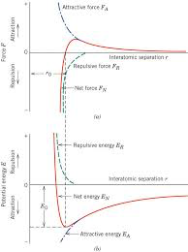
  + E = ∫ Fdr
    - Minimize energy to make atoms happy
    - Look at dip in net energy curve above
    - That is the optimal atomic distance for bonded atoms
  + Ionic forces for ion pairs
    - Nucleus of one atom attracts electrons of another
      * But as they get too close, the oppose because of electron clouds reacting
 $F{}_{A}=$ $\frac{(|Z{}_{1}^{}|e)(|Z{}_{2}|e)}{4πε{}_{0}a{}^{2}}$    * Z = number of electrons removed or added during ion formation
      * e = electric charge (1.602x10-12 C)
      * a = interionic separation distance
 $F{}_{R}=$ $\frac{nB}{a{}^{n+1}}$

  - * n and B are constants
        + n is usually 8
    - $F{}_{N}$ = $F{}_{A}$- $F{}_{R}$ = $\frac{(|Z{}_{1}^{}|e)(|Z{}_{2}|e)}{4πε{}_{0}a{}^{2}}$- $\frac{nB}{a{}^{n+1}}$
  + Interionice energies for ion pairs
    - E = - $\frac{(|Z{}_{1}^{}|e)(|Z{}_{2}|e)}{4πε{}_{0 }a}$ + $\frac{B}{a{}^{n}}$ = bond energy
      * Remember E = ∫ F da
  + Ion arrangements in ionic solids
    - Non Directional
    - Present to maintain electrical neutrality
    - Lattice energies
      * Related to the bond strength
        + Not exactly the same
      * Energy required to separate the solid into gaseous ions
      * Usually decreases when size increases
  + Covalent bonding
    - Outer s and p electrons are shared
    - Energies are lowered (more stable) because the electron interaction
  + Metallic bonding
    - Crystal structure
    - Electrons spread out among atoms forming electron clouds

## Summary

* + Electrons in atoms
    - Bohr model
      * Electrons are particles orbiting the nucleus in discrete paths
    - Wave mechanical
      * We consider them to be wave like and treat electrons position in terms of probability distribution
    - Electron energies are quantized
      * Only specific values of energy are allowed
    - Quantum numbers
    - Pauli exclusion principle
      * Electron states can only hold 2 electrons
  + Bonding forces and energies
    - Equations 2.5a and 2.5b
  + Primary interatomic bonds
    - Ionic bonds
      * Electrically charged ions are formed by the transference of valence electrons from one atom type to another
    - Covalent bonding
      * A sharing of electrons
  + Secondary bonding, van der waals bonding
    - Fairly week
  + Mixed bonding
    - Types
      * Covalent ionic
      * Covalent metallic
      * Metallic ionic
    - %IC, percent ionic character
      * How ionic a bond is,
        + 0% is purely covalent, 100% is purely ionic
      * A bond between two elements depends on their electronegativity (X’s) according to Equation 2.16

# Chapter 3 The Structure of Crystalline Solids

## [Atomic Structure Basics](https://lms.uconn.edu/bbcswebdav/pid-4334816-dt-content-rid-62077522_1/courses/1208-UCONN-MSE-2101-SEC001-3862/Mod2.LecA.Ch3%20-%20Structure%20Basics.pdf)

* + How do atoms assemble together
    - Two or three, or even several atoms together make molecules
  + But what if we have trillions
    - We have structures
    - 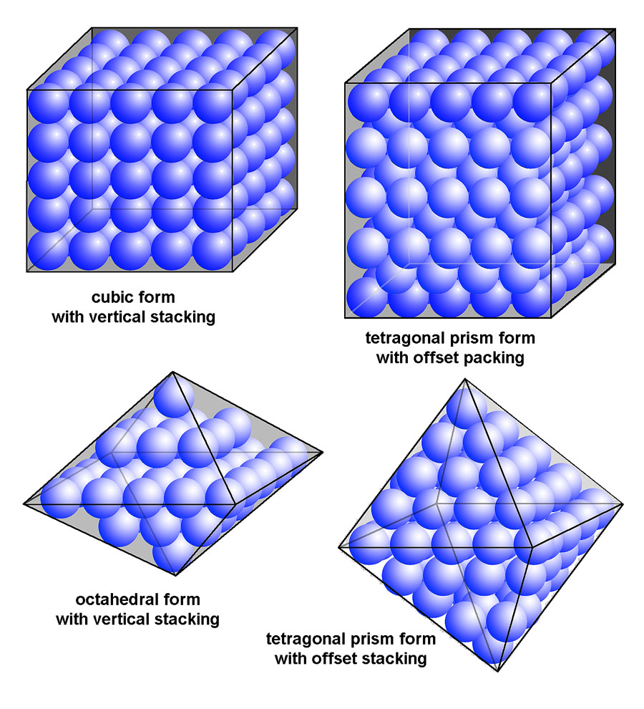
    - An ordered array of atoms
  + Structure of inorganic solids
    - Imagine a grid of atoms
    - Long range order (LRO)
      * Order exhibited over a distance greater than the bond length
      * Distance from neighboring atoms is relatively the same
    - Short range order (SRO)
      * Distances to neighbor is maintained but it is not constant in different areas of the structure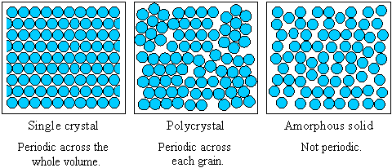
  + Crystalline or amorphous solids
    - Crystalline
      * Exhibit LRO and some SRO
    - Amorphous
      * Exhibs only SRO
    - 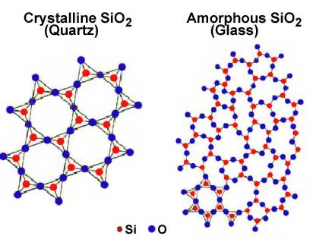
    - Quarts is LRO, Glass is only SRO in the bottom right corner
    - Metals are usually crystalline
    - Ceramic and polymers may by either
  + Amorphous materials
    - Polymers
      * Secondary bonds do not allow formation of parallel and tightly packed chains during solidification
    - Ceramics
      * Amorphous
      * Typically called glass
      * SRO only
    - Metals can be amorphous if cooled REALLY fast
      * Called metallic glasses, not covered in this course
  + Differences between crystalline and amorphous
    - Crystalline
      * Well-defined melting point
      * Specific cleavage planes for ionic solids
        + Fracture surfaces
      * Cluster of ordered crystals form
        + 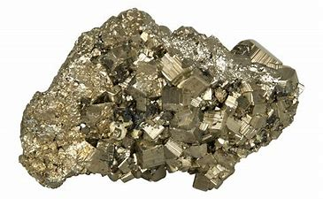
    - Amorphous
      * Soften slowly over a range of temperatures
      * Irregular or curved fracture surfaces
        + 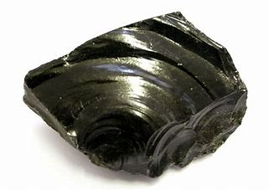
  + Key points
    - Atoms assemble into structures
    - Structures can exhibit SRO or LRO
    - There are differences in materials properties for SRO and LRO

## [Unit Cells and Densities](https://lms.uconn.edu/bbcswebdav/pid-4334811-dt-content-rid-62077523_1/courses/1208-UCONN-MSE-2101-SEC001-3862/Mod2.LecB1.Ch3%20-%20Unit%20Cell.pdf)

* + Space lattice and unit cell
    - Space lattice
      * An imaginary network of lines, with atoms arranged around and on the intersection of lines
    - Unit cell
      * Smallest repeating block of atoms in a space lattice
    - 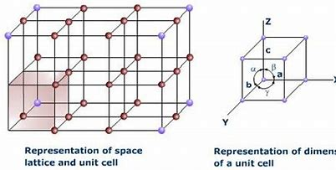
    - Lattice points
      * Intersections of the imaginary grid
        + Vertices of the unit cell
    - Lattice vectors
      * Vectors that outline the unit cell. a,b, and c above
    - Lattice constants
      * Axial lengths, a,b,and c, and the interaxial angles
  + Coordination number and atomic packing factor APF
    - Coordination number
      * How many atoms are touching a given atom
      * The number of nearest neighbor atoms
    - APF
      * Ration of space occupied by atoms vs empty space
      * APF = Volume of atoms in a unit cell / total unit cell volume
  + Type of unit cells
    - There are 7 crystal systems and 14 standard unit cells
    - 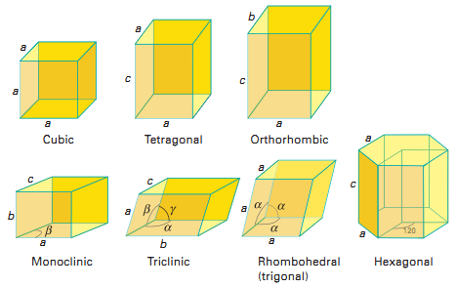
      * Cubic unit cell
        + a = b = c
        + o
        + 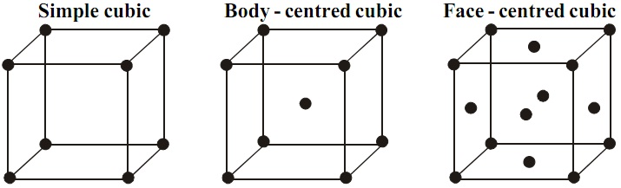
      * Tetragonal
        + (a = b) != c
        + o
        + We can have simple and body-centered
      * Orthorhombic
        + a != b != c
        + o
        + 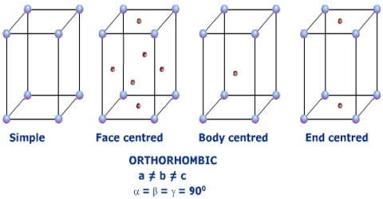
      * Rhombohedral
        + a = b = c
        + (o

Only simple

* + - Directions in cubic crystals
      * 3 numbers within brackets
      * Ex

$[111]$

$[1\bar{2}0]$

Bar means negative

* + - Miller indices
      * h = 1/x-intercept
      * k = 1/y-intercept
      * l = 1/z-intercept
      * Written
        + (hkl)
      * If a plane intersects a whole axis or origin, the origin must be moved to another corner
      * Always divide by a common factor to get the smallest possible integer
  + Face Centered Cubic
    - 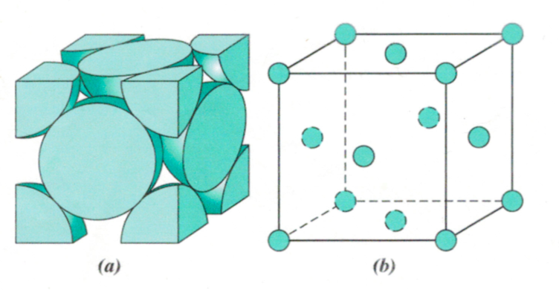
    - 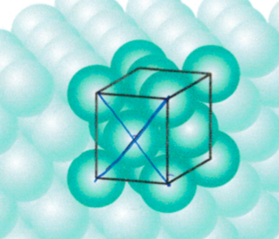
    - Number of atoms per unit cell
      * 4
    - Edge length
 $a=2R\sqrt{2}$

   - Volumetric fraction/atomic packing factor
      * 74%
    - This is an example of a close-packed structure
  + Body centered cubic
    - 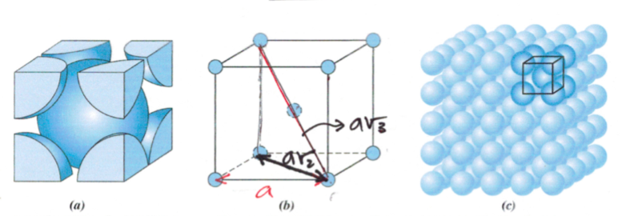
    - Number of atoms per unit cell
      * 2
    - Edge length
 $a=\frac{4R}{\sqrt{3}}$

   - Volumetric fraction
      * 68%
  + Simple cubic packing
    - 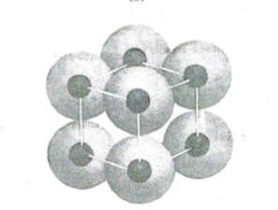
    - Edge length
 $a=2R$

   - Volumetric fraction
      * 52%
    - Very open structure
    - Also very weak
  + Density
    - Theoretical
 $ρ=\frac{nA}{V_{C}N_{A}}$

   - In reality n < expected for a packing type so real volume is less. There are also other gaps in between grains

# Chapter 12 Structures and Properties of Ceramics

* Ceramics
  + Composed of at least two elements
  + Bonding can be purely ionic to totally covalent
* Face centered unit cell
  + Has 4 atoms, 4 octahedral voids, or 8 tetrahedral voids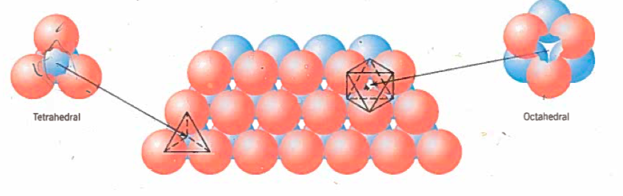
  + Tetrahedral position
    - Three in one plane and one atom out of plane
  + Octahedral position
    - 6 ions joined, 3 in each of 2 planes
* Pauling’s law of stability of ionic, or mainly ionic, crystal structures
  + The number of anions around a cation is determined by the ratio $\frac{r_{c}}{r_{a}}$ of the cation radius to the anion radius
  + 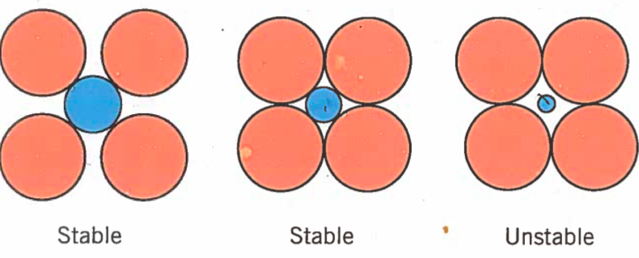
    - Ensure the ratio is within the numbers from Table 12.2 (Coordination Numbers and Geometries for Various Cation-Anion Radius Ratios)
    - 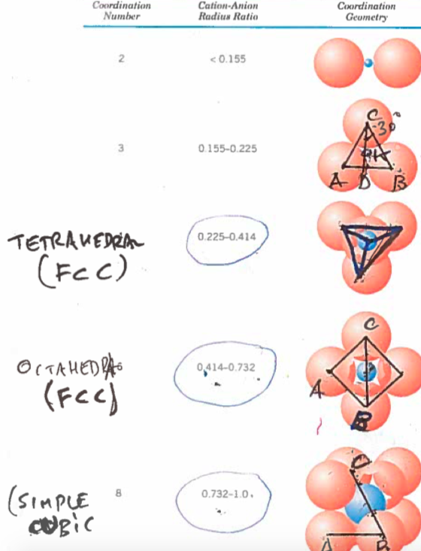
    - Table 12.3 gives ionic radii for several cations and anions
    - Get structure from Table 12.4

## Theoretical ceramic density

* + - Where:
      * $n'=$ the number of formula units within the cell
      * $\sum{}A_{c}$ = The sum of all different cations atomic weight
        + If there is only one type of cation then it’s just $A_{c}$

Mass of the single cationn

* + - * = The sum of all different anions atomic weight
        + If there is only one type of anion then it’s just $A_{A}$

Mass of the single anion

* + - * cell volume
      * $N_{A}=$ Avogadro’s number
  + Silicate ceramics
    - Materials composed of silicon and oxygen
  + 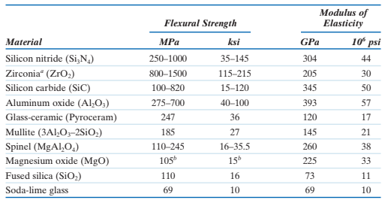

# Chapter 4 Imperfections in Solids

* Types of defects
  + Point defects
    - Only one or two atomic positions
  + Linear deficiencies
    - A one dimensional error
  + Vacancies
    - Missing an atom
  + Self-interstitial
    - Atom in a place that should be empty

## Vacancy Equation

## 

* + - * Fractional vacancy concentration: $\frac{N_{V}}{N}$
        + $N_{v}=$ The equilibrium number of vacancies
        + $N=$ The total number of atomic sites (per cubic meter)

$N=\frac{N_{A}ρ}{A}$

$N_{A}=$ avogadro’s number

$ρ =$ density

$A=$ atomic weight

* + - * + the energy required for the formation of a vacancy (J/mol or eV/atom)
        + $k=$ Boltzmann constant, (1.38e-23 J/(atom*K) or 8.62e-5 eV/(atom*K))
 $R=kN_{A}$

 $T =$      + temperature in Kelvin
    - Arrhenius plot
$ln(\frac{N_{v}}{N})=(-\frac{Q_{v}}{R})\frac{1}{T}$

$y=ln(\frac{N_{V}}{N}), x=\frac{1}{T}, m=\frac{Q_{V}}{R}$

$y= -mx$

* Solid solutions
  + 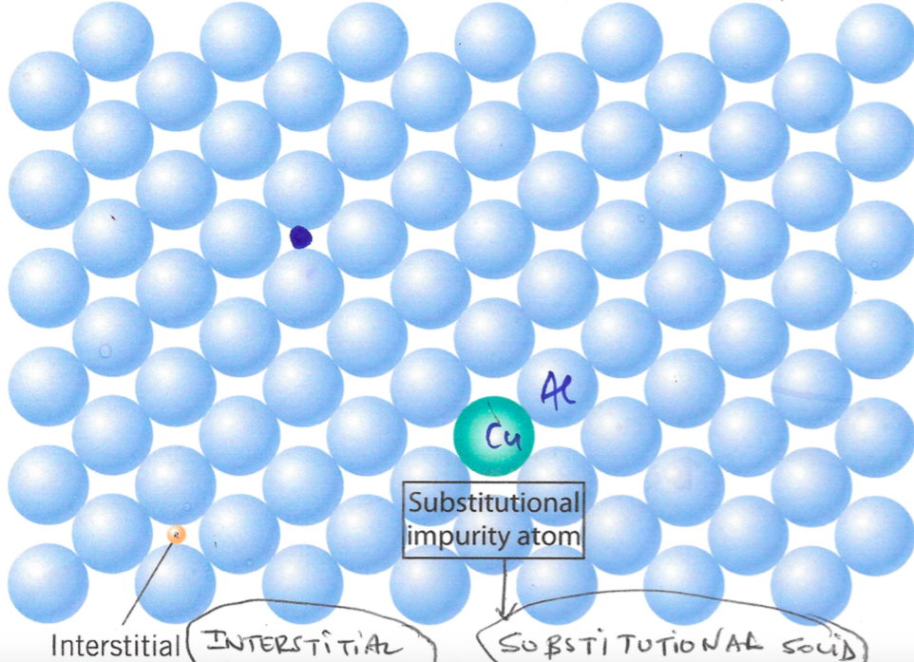
  + Types of point defects
  + Substitutional impurity atom
    - Impurity atom replaces normal atom
    - Hume-Rothery Rules
      * Atomic size factor
        + Impurity must be $±15\%$ radii
      * Crystal structure
        + Atoms must have same crystal structure, FCC
      * Valence
        + Atoms must have the same valence electrons
      * Electronegativity factor
        + Need to have similar electronegativities
  + Interstitial impurity atom
    - Impurity atoms fill voids

## Composition/Concentration

* + Weight percent (wt%)
 $C_{1}=\frac{m_{1}}{m_{1}+m_{2}}×100$

 + Atom percentage (at%)

$C_{1}'=\frac{n_{m1}}{n_{m1}+n_{m2}}×100$

$n_{m}=\frac{m}{A}$

## Dislocations

* + A linear or one-dimensional defect around which some of the atoms are misaligned
  + 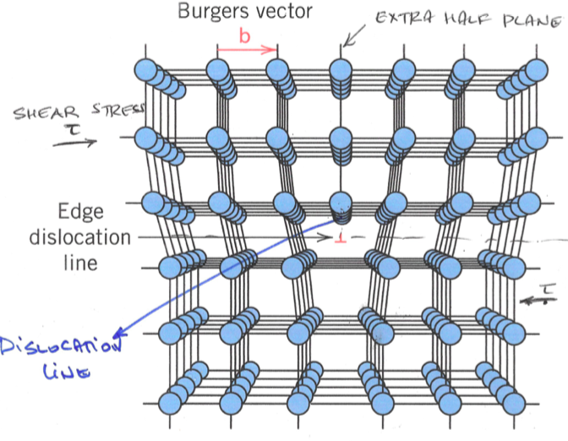
  + Screw dislocation
    - Formed by a shear stress
    - Discocoation line is parallel to force
    - 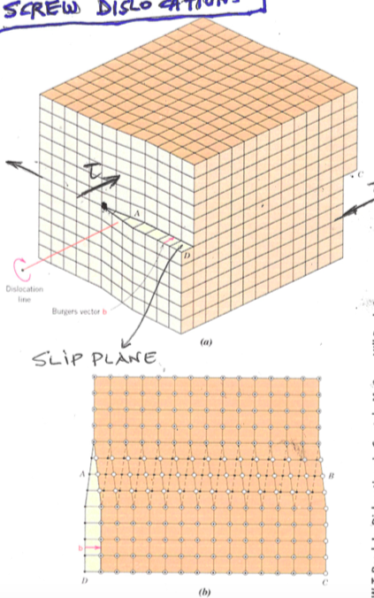
  + Mixed dislocation
    - 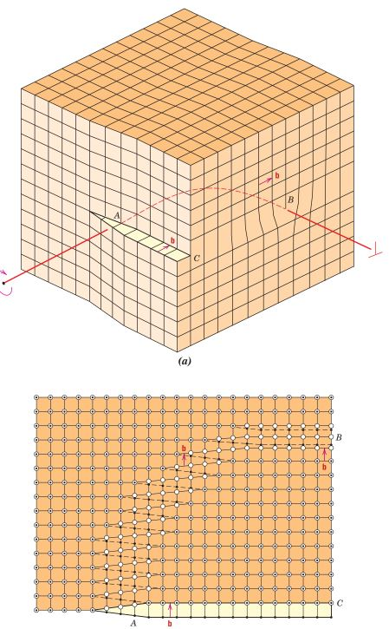
  + Low angle tilt
    - 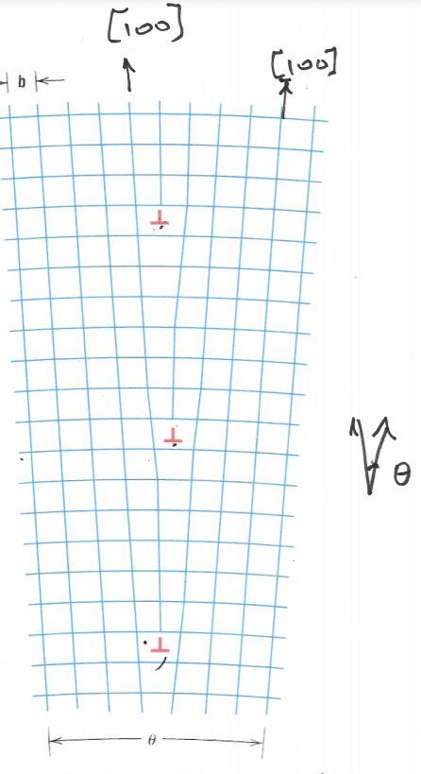

# Chapter 5 Diffusion

* What is diffusion
  + Material transport via atomic motion
  + 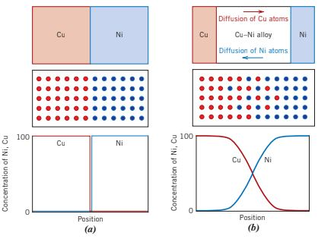

## Interdiffusion zone (L)

* + - Zone where diffusion is occuring
 $L=k\sqrt{Dt}$

   - * Where L is the length of the zone and D and k are a constant
  + Types of diffusion
    - 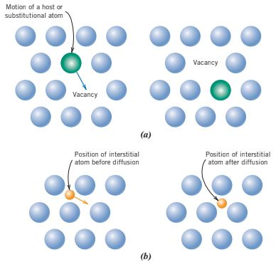
    - (a) Vacancy diffusion
      * Atoms fill vacancy spots
    - (b) Interstitial diffusion
      * Smaller atoms weave through the gaps

## Fick’s first law

* + Diffusion is a time-dependent process
    - The amount of diffusion that occurs is a function of time
  + How fast diffusion occurs
    - Rate of mass transfer
    - Diffusion flux (J)
 $J=\frac{M}{At}$     * Where:
        + $M=$ mass or number of atoms
        + $A=$ area across which diffusion is occuring
        + $t =$ time
      * The units for diffusion flux are ($kg/(m^{2}⋅s)$) or ($kg/({atoms}^{2}⋅s)$)
    - Steady state diffusion of gas through a material in single direction x
      * 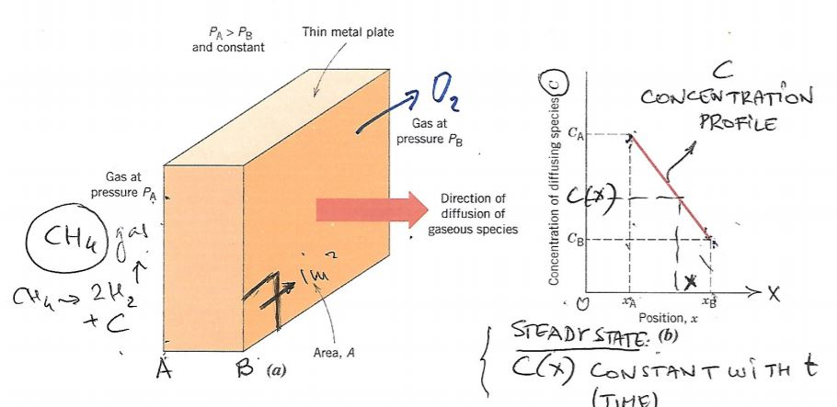
      * Diffusion flux: $J=-D\frac{dC}{dx}=-D\frac{ΔC}{Δx}$
        + D is the diffusion coefficient $\frac{m^{2}}{s}$ and C is concentration $\frac{kg}{m^{3}}$

## Fick’s second law

* + Non-steady state diffusion
 $\frac{δC(x,t)}{dt}=D\frac{δ^{2}C(x,t)}{δx^{2}}$

   - Semi-infinite solid: $l>10\sqrt{Dt}$
      * Conditions:
        + Uniform initial distribution $C_{o}$ at t=0
        + x=0 is at the surface of the solid
        + t=0 at beginning of diffusion
 $\frac{C_{x}-C_{0}}{C_{s}-C_{0}}=1-erf(\frac{x}{2\sqrt{Dt}})$

 $C_{s}$      + is concentration at surface

### concentration at point x is

* + - * Generally solve for what erf() equals and look at table
    - 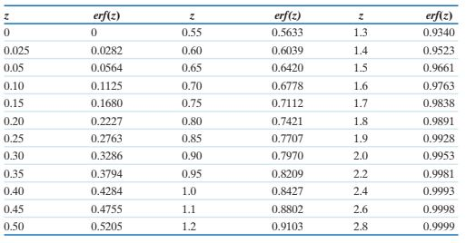
      * 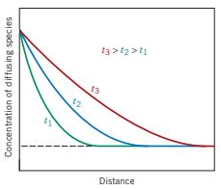
    - Depth of penetration
      * The depth at which we can find a specific concentration $C_{1}$
 $\frac{C_{1}-C_{0}}{C_{s}-C_{0}}=Constant=1-erf(\frac{x}{2\sqrt{Dt}})$

       + Therefore $\frac{x}{2\sqrt{Dt}}=Constant$

Therefore $\frac{x^{2}}{Dt}=Constant$

If constant D too then $\frac{x^{2}}{t}=k$

Also $x^{2}=kt$ and $\frac{x^{2}}{k}=t$

So to double the penetration depth, time must be quadrupled

If constant object, x

$Dt=constant=D_{2}t_{2}$

## Factors that influence diffusion

* + Temperature
 $D=D_{0}exp(-\frac{Q_{d}}{RT})$

 $D_{o}$  - * is a temperature-independent constant
      * $Q_{d}$ is the activation energy for diffusion $J/mol$ or $eV/atom$
      * R is the gas constant $8.31 J/(mol⋅K)$ or $8.62×10^{-5}eV/(atom⋅K)$
      * $T$ is temp in Kelvin
    - 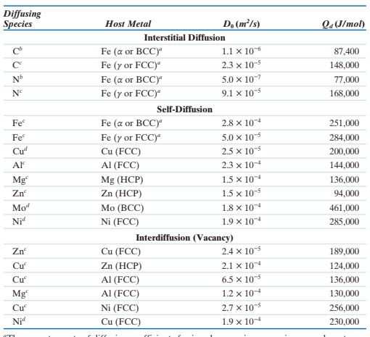

# Chapter 6 Mechanical Properties

* Ways to test
  + Tension/compression loading
    - Gauge length
 $l_{o}$

   - Volume does not change

## Stress and Strain

* + where $A_{i}$ is the instantaneous cross section area
  + - K and n are constants
* Table 6.1
  + 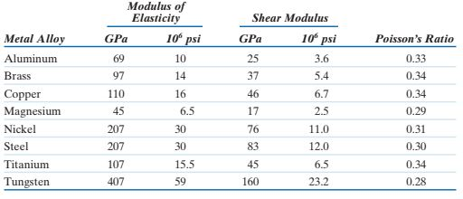
  + Attraction energy graph
    - Young's modulus is proportional to tangent of this graph at F=0
    - $E∝(\frac{dF}{dr})$ evaluated at $r_{o}$ aka r intercept on the graph

## Poisson's ratio

* + - Should always end up being positive
    - For metals
 $0.25<ν<0.35$

   - Isotropic materials
      * The same mechanical properties in all directions

$ν=0.25$

## Shear loading

$G=\frac{E}{2(1-ν)}$

$τ=Gγ$

## Ductility

* + percent elongation
  + $\%RA = \frac{A_{o}-A_{f}}{A_{o}}×100$ percent reduction in area
  + Brittle materials have a very low fracture point
  + Ductile materials have a high fracture point
* Properties of a stress strain graph
  + 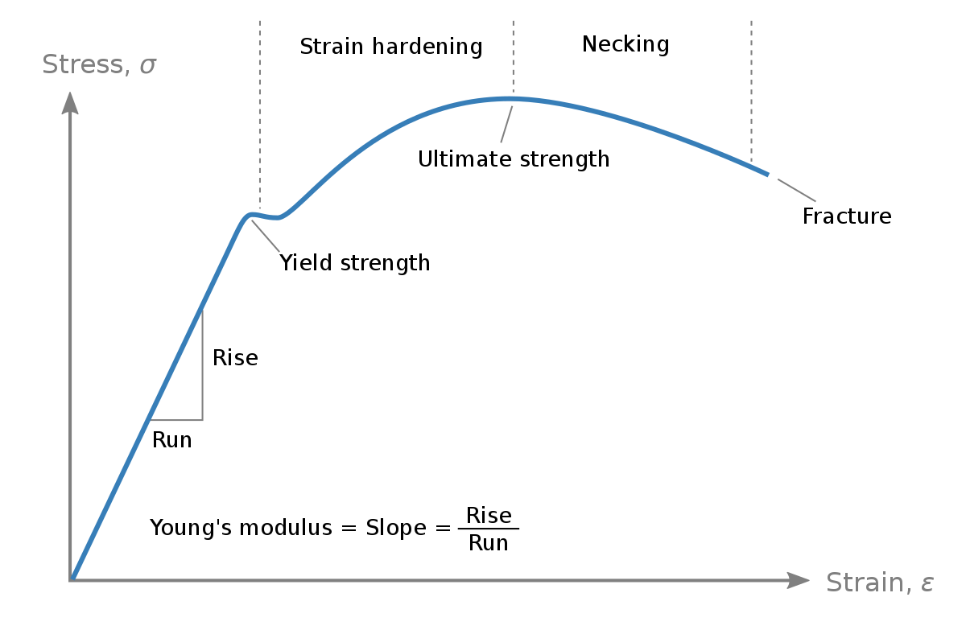
  + Ultimate strength is also called tensile strength
  + Area under to a specific strain is energy expended during deformation per cubic meters
 $J/m^{3}$

 + Tensile fracture, toughness
    - Area under total graph
  + Under static conditions
    - Deformation is very slow
  + Table 6.2 gives strengths for materials

## Resilience

* + - Capacity of a material to absorb energy when deformed elastically
    - $U_{r}=\int_{0}^{ϵ_{y}}{}σdϵ=\frac{1}{2}σ_{y}ϵ_{y}$ for linear elastic regions
  + After plastic deformation, the material travels along a young’s modulus line and ends with some permanent elongation
    - 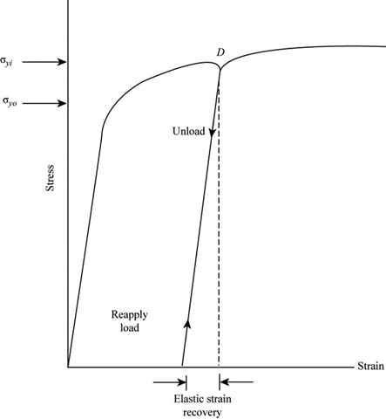

## Brinell Hardness test

* + Pushed spheres into materials to see their deformation
    - Dimensions of the indentations relate to the metals hardness
  + Tensile strength (MPa) = 3.45 x HB (Brinell Hardness)
* 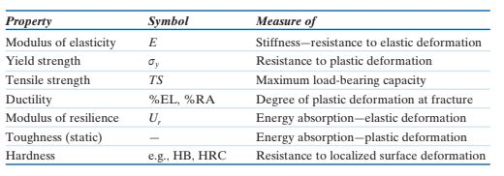

# Exam:

1-2: numerical

3: has a,b,c parts 1-2 sentences each

4: Miller indices

5: ch5/diffusion question

6: numerical ( have to use two formulas from ch 7)

# Chapter 7 Dislocations and Strength Mechanics

* Slip
  + The process that makes plastic deformation
  + 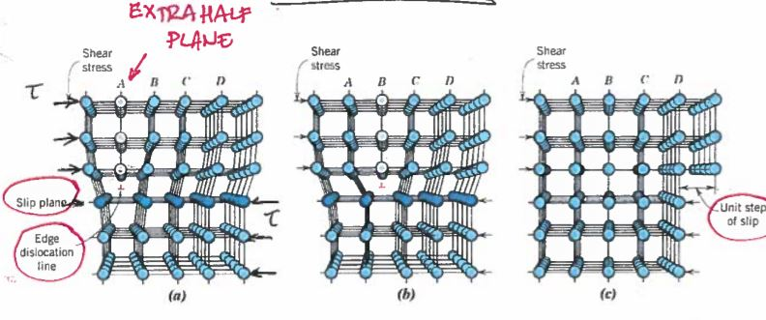
  + Extra half plane causes extra compression
  + Near it is in tension to compensate

## Slip plane notation

* + FCC
    - (111) [110]
    - Plane then direction
    - {111}<110>
    - Includes all combination of plans and directions, negative and positive
    - Slip plane is in Table 7.1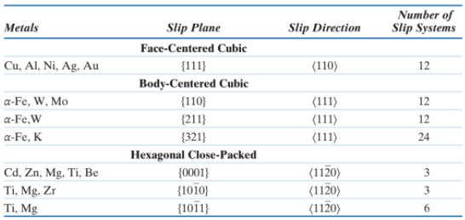
* Slip in single crystals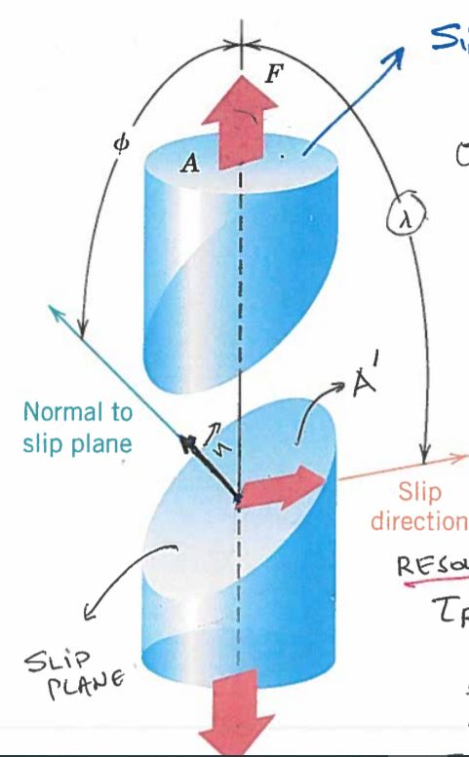
 $τ_{R}=σcos(ϕ)cos(λ)$

 $σ_{y}=\frac{τ_{R max}}{(cosϕcosλ)_{max}}$

+ Most important property of a material is yield strength

## Mechanisms of strengthening(hardening) of metals

* + Grain refining

## Hall-Petch equations

* + - * + and $k_{y}$ are metal constants
        + $d$ is the average grain diameter
      * This equation is not true for really large or small grains
      * As average grain size goes down, toughness goes up
    - Obstacles of dislocation motion: Grain Boundaries
  + Solid solution strengthening
    - Add impurity atoms to go into and break up the solid solution
    - Obstacles of dislocation motion: Stress/strain fields around guest (solute) atoms
    - 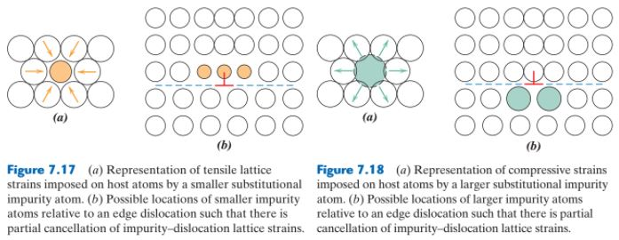
  + Precipitation strengthening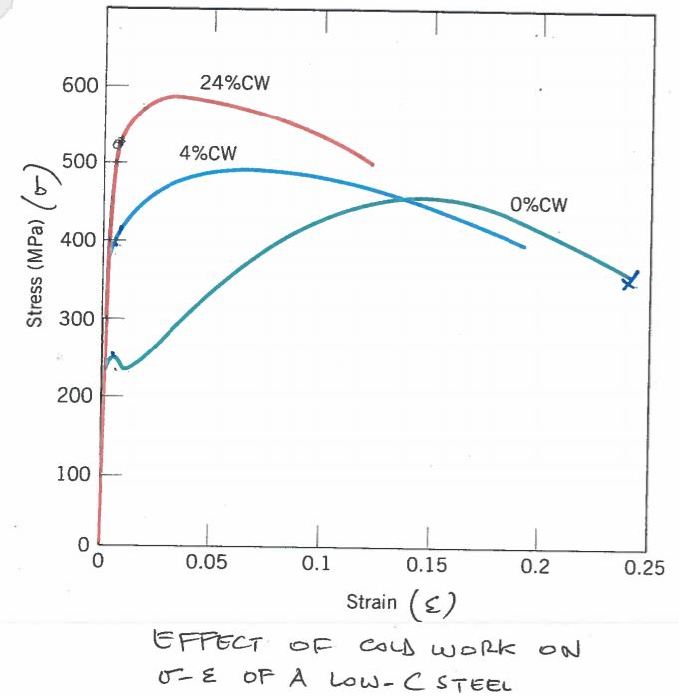
  + Strain hardening-cold working
 $\%CW=(\frac{A_{o}-A_{d}}{A_{o}})×100$

 $A_{d}$  - * is cross-section after deformation
    - This process increases yielding strength but makes the material a lot more brittle

## Recrystallization

* + At high temperatures crystals have elongated grains, high density, and high strain energy
  + Recrystallization: Making crystals strain free of strain energy
  + Annealing (Heat-Treating at high temperature) of a cold worked component
    - Decreases dislocation numbers
    - Decreases electrical resistivity
    - Increase thermal conductivity
    - Recrystallizes
    - Increases grain size
 $d^{n}-{d_{o}}^{n}=Kt$

 + Recrystallization Temperature
    - Temereration it takes to make complete recrystallization in 1 hour
    - 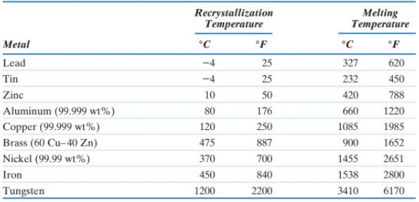

# Chapter 8 Failure

* 3 kinds of fracture
  + Plastics
  + Ductile fracture
    - Necking
    - Rigid fracture surface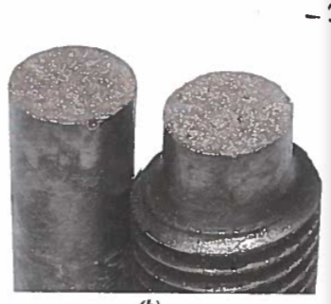
  + Brittle fracture
    - Minimal necking
    - Straight fracture surface

## Crack types

* + Intergranular cracks
    - Cracks straight through everything
    - Bodies are weaker than boudry
    - Cracks straight through the body
  + Transgranular cracks
    - Grain boundaries are weaker than grain body
    - Grain follows the boundary

## Orocoan theory of brittle fracture

* + Two cracks propagate in two opposite directions
  + Fracture occurs along X
  + Tension opens the crack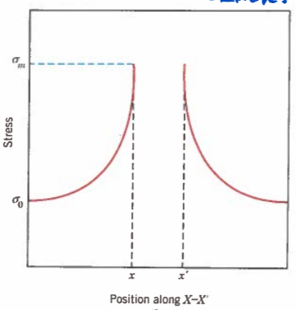
  + 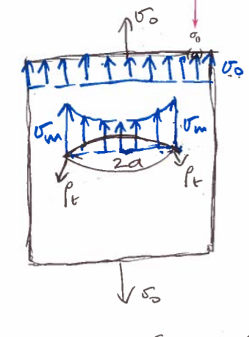
    - 2a = crack length
    - $ρ_{t}$ = tip radius
    - $σ_{m}$ = max stress at tip = $2σ_{o}\sqrt{\frac{a}{ρ_{t}}}$
    - $σ_{o}$ = applied stress
    - Stress concentration factor: $K_{t}=\frac{σ_{m}}{σ_{o}}=2\sqrt{\frac{a}{ρ_{t}}}$

## Critical stress for crack propagation

* + - Opens up the crack when $σ_{m}$ reaches $σ_{c}$
 $σ_{c}=σ_{f}=\sqrt{\frac{2Eγ_{s}}{πa}}$     * Stress to apply to open up the crack
      * $γ_{s}$ is specific surface energy ($\frac{J}{m^{2}}$)
      * Energy of the atoms connecting the surface

## Fracture toughness: how strong and ductile

* + Tensile loading Mode I
    - Materials resistance to brittle fracture when a crack is already present
    - Y is a constant depending on crack and specimen shape and size and mode of load application
    - $K_{IC}$ means the specimen thickness is much greater than the crack length
    - Properties
      * Lower temperature means more brittle, K goes down
      * Stronger materials, K goes down
      * As grain size increases, K goes down
* Loadings
  + Static, slow loading
  + Dynamic, immediate loading
  + Impact loadings
    - Impact energy of an object swinging down
 $mgΔh$

   - 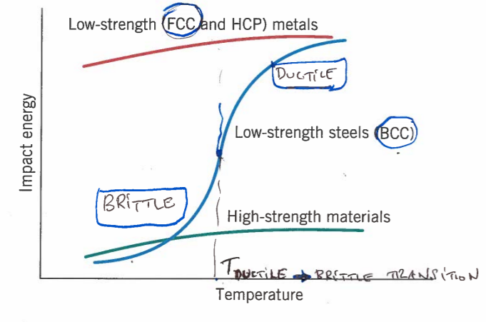
    - Notch impact energy vs T
      * Transition temperature depends on microstructure and composition
      * As grain size goes down, transition goes down
      * As %C goes up, Transition goes up
    - We want materials with lowest transition as possible

## Fatigue

* + Cracks
    - Crack formings is much more energy than crack propagation
  + Loading
    - Tension-compression cycles
    - $σ_{max}$ is in tension, $σ_{min}$ is in compression
    - $σ_{m}=\frac{σ_{max}+σ_{min}}{2}$ Mean stress
    - $σ_{R}=σ_{max}-σ_{min}$ Stress range
    - $σ_{a}=\frac{σ_{max}-σ_{min}}{2}$ Stress amplitude
    - $R=\frac{σ_{min}}{σ_{max}}$ Stress ratio
    - 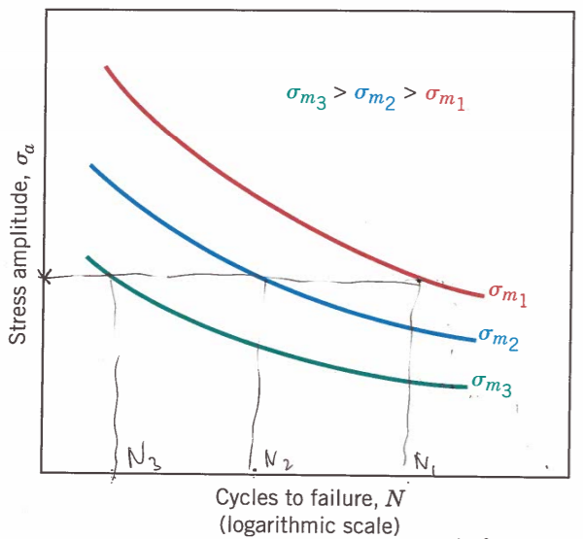
  + To improve fatigue life (N) **Can only change the outside**
    - Polish component surface
      * Fix hairline fractures
    - Avoid sharp corners
      * Lower stress concentration $K$
    - Surface layer under compression
      * Tensile strength is offset by the constant preconcentration
    - Place surface layer under compression by
      * Shot peening
        + Curved indentations form a layer under compression
        + Inside surface is under tension
      * Surface carburizing/nitriding

## Creep strain/deformation

* + Permanent deformation at $T>\frac{1}{2}T_{M}$
  + If placed in elevated temperature, grain boundary slide and object grows
    - Elevated temperature T
    - $T_{m}$ is melting temperature
    - Equation only works in Kelvin
    - 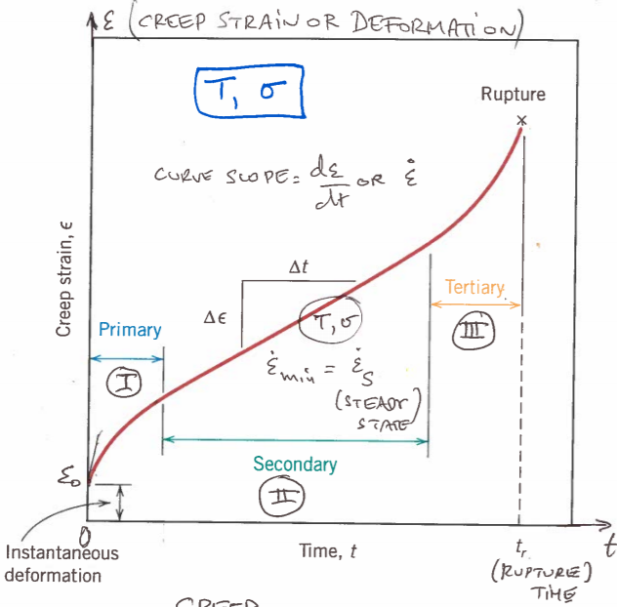
    - Red line is a constant stress or constant temperature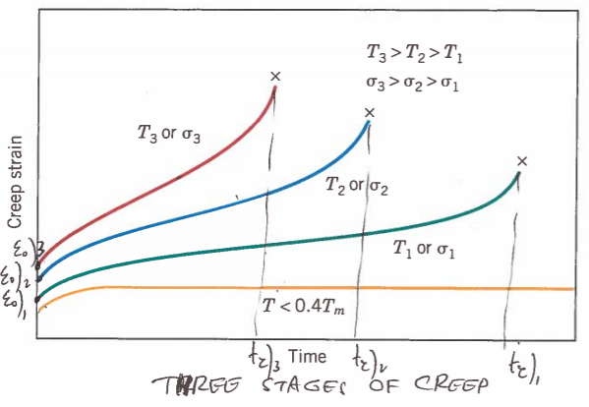
    - I: as time increases, $\dot{ϵ}$ decrease
    - II: Steady creep rate increase
    - III: As time increases, $\dot{ϵ}$ increases

# Chapter 9 Phase Diagrams

* Intro to phases
  + Component
    - The pure metals (or compounds) of which an alloy is composed of
    - For brass
      * Its components are Cu and Zn
  + Phase
    - Physical and chemical characteristics of the components
    - Also characteristics of mixed religions
  + Solubility limit
    - Max concentration of solute in solvent
    - 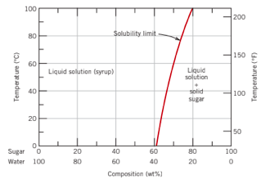
  + Equilibrium
    - Minimized free energy for a Temp, Pressure, and composition
    - Lowest energy phase for composition and temperature
    - Free energy
 $ΔG^{o}=ΔH^{o}-TΔS^{o}$     * Internal energy stored in a system
  + Phase equilibrium
    - Equilibrium for a system with more than one phase
    - Metastable
      * State as you approach equilibrium but it’s at nonequilibrium
  + Phase diagram
    - Which phases are present at particular temperatures and compositions and pressure
    - Single compound example:
      * 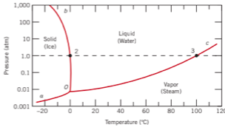
    - Pure Iron phase diagram
      * 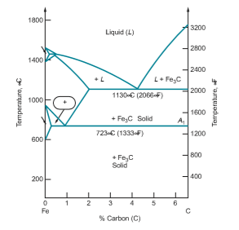
      * Has solid liquid gas
      * Under solid it also has temp and pressure for
        + BCC solid
        + FCC solid
      * Cooling curves
        + 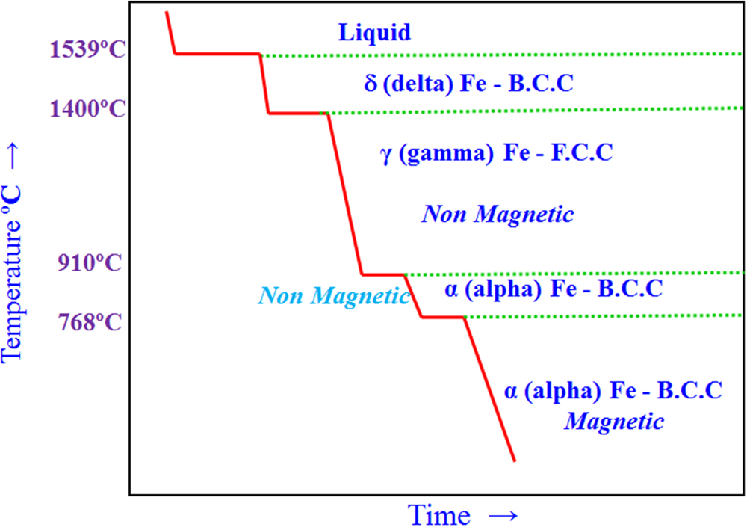

## Reading phase diagrams

* + Binary isomorphous alloy
    - 2 element system
    - Completely soluble in all phases
    - The two elements have different pure melting temperatures
      * As we combine them, they have a range of melting temperature
      * 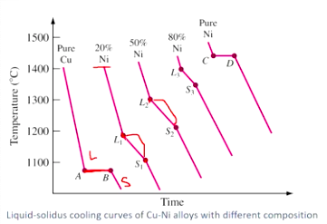
      * 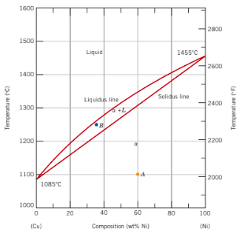
      * Pure copper ment is 1100 but pure nickel is 1400
        + Inbetween gives a range of solidification temperatures
        + Point A is 100% $α$ phase
        + Point B is in the two phase region

Mixture of $α$ and L phase

Bulk composition is 35 wt%

Changing this can change the phase

* + - Lever rule, the amount of $α$ or L in a two phase region
      * 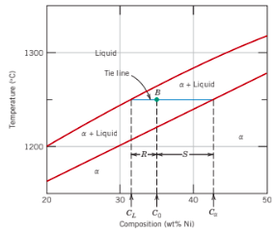
      * Mass fraction of solid phase $\frac{R}{R+S}$
 $W_{α}=\frac{C_{o}-C_{L}}{C_{α}-C_{L}}$     * Mass fraction of liquid phase $\frac{S}{R+S}$
 $W_{L}=\frac{C_{o}-C_{α}}{C_{α}-C_{L}}$

 + Binary Eutectic alloy system
    - Different solid solubility for different compositions/temps
      * 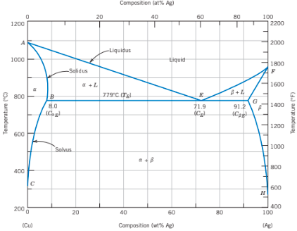
      * $α+β$ Phase
        + Combination of copper solid phase and silver solid phase
    - Eutectic point
      * Point E on above diagram
      * Special temp and composition
      * Go straight from liquid to $α+β$ Phase
        + Lowest freezing point for the system
    - Eutectoid
      * From one solid phase to two solid phases
      * Cooling
    - Peritectic
      * 1 solid and 1 liquid to 1 solid phase
      * Also cooling
    - Peritectoid
      * 2 solid phases to one solid phase
    - Congruent phase change
      * 1 phase to 1 phase
    - Incongruent phase change
      * 1 to 2
      * Or 2 to 1

## Microstructural development

* + Equilibrium cooling
    - Infinitely slow cooling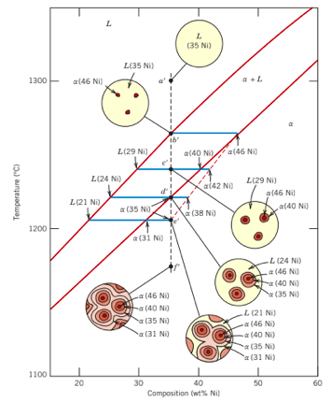
    - As cooled
      * First get 46% Ni solid and liquid mixture
      * Then 43% Ni solid and 32% Ni liquid mixture
      * Then 24% Ni liquid and solid mixture
      * Then ends with at solidus with 35% Ni solid
      * This is diffusion
        + Copper and nickel atoms rearrange themselves to get propper %’s
        + Nickel diffuses out
      * Each solid formed has less and less nickel
  + Non Equilibrium cooling
    - Don't have time to fully diffuse
    - Material has small cores of higher concentrations
      * Microsegregation coring
  + Binary eutectic cooling
    - Cooling at eutectic point
      * Liquid becomes both phases at onces
    - Cooling through $α$ + L to $α+β$ Phase
      * You get some $α$ growth and then surrounded by $α+β$ liquid becoming $α+β$ solid
      * $α$ is the primary proeutectic phase
      * Microconstituents are the 2 phases
        + The pure $α$ and the $α+β$
    - Lever rule still works

## Iron-Carbon System

* + Steel is between 0.022 and 2.14 wt% Carbon
  + 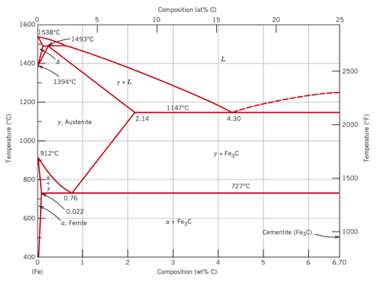
  + More than 2.14 wt% carbon is Cast Iron
  + Equilibrium phases
    - $δ$ Ferrite ($δ$-Iron, BCC)
    - Austenite ($γ$-Iron, FCC)
    - Ferrite ($α$-Iron, BCC)
    - Cementite ($Fe_{3}C$)
  + Non-equilibrium phases
    - Perlite
      * Layered mix of ferrite and cementite
    - Bainite
      * Not layered mix of ferrite and cementite
    - Martensite
      * Doesn’t show up on the equilibrium phase diagram
      * BCT
  + Microstructures we see in Fe-C system
    - Plain carbon steel, just iron and carbon
    - Slow cooling
      * 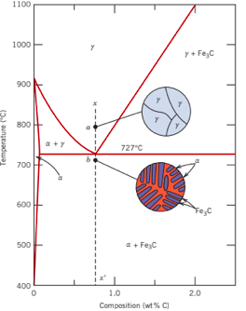
      * We have a eutectoid point
      * Go from austenite to ferrite and cementite
        + This ferrite and cementite is called pearlite
    - Hypoeutectoid steel, left of eutectic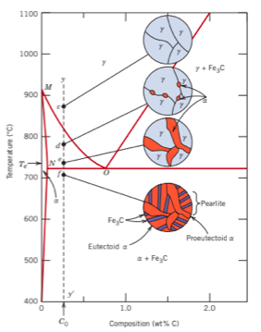
      * Austenite to Ferrite + Austenite
      * Then to perlite
    - Hypereutectoid steel, right oe eutectic
      * 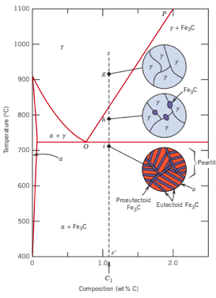
      * Austenite to Cementite + Austenite
      * Then to perlite

# Chapter 10 Phase Transformations

## Phase transformations

* + Moving from one phase to another
  + 3 types
    - Diffusion dependent
      * No change in the number or composition of phase
        + Like going from solid ice to liquid water, same composition
      * Different number or composition of phases
        + Like liquid to eutectic, 2 phase solid

Liquid phase is 62 wt% Sn

Alpha phase is 18 wt% Sn

Beta phase is 97.8 wt% Sn

* + - Diffusionless
      * Metastable phases, not lowest equilibrium energy but still stable
  + Why do we care about phase transformation?
    - Because it changes mechanical and other properties of materials
  + Kinetics
    - The reaction over time
    - Rate of a solid state transformation
      * Rate = $\frac{1}{t_{0.5}}$
        + Time for half of the transformation
    - Lower temperatures lead to lower rates

## Thermal Processing of Steel

* + Steels
    - Austenite
      * Slow cooling (Close to equilibrium cooling)
        + Pearlite
      * Moderate cooling
        + Bnite
      * Rapid quench
        + Martensite
        + Reheat

Tempered martensite

* + - Transformation diagrams
      * 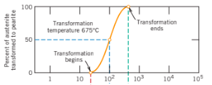
        + Percent transformed vs time
      * 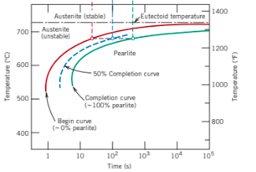
        + Temperature vs time
        + Time-Temperature-Transformation diagram
        + 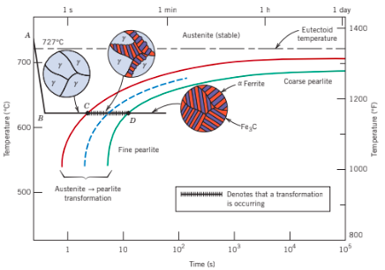

Bainite

This one just shows the microstructures

* + - * + Needs another curve for lower temperatures

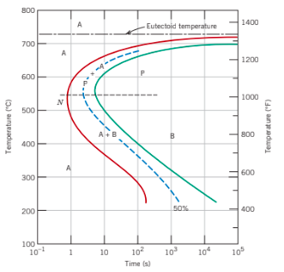

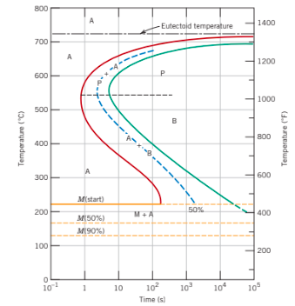

Martensite on the diagram

It is Athermal, so it only depends on cooling, not time

Just not enough energy to rearrange itself

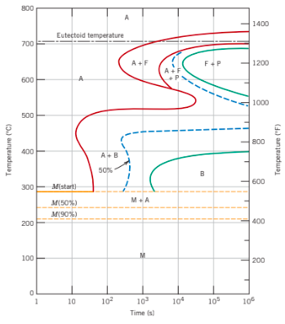

Hypoeutectic steel martensite forming

* + - * + CCT Diagrams

Continuous cooling since we can't cool instantly

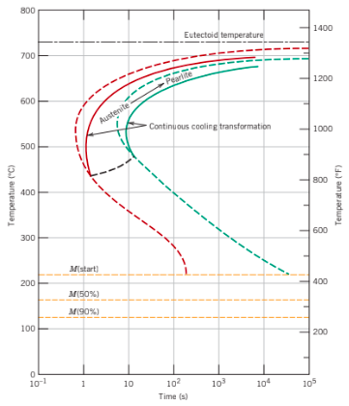

* + Mechanical properties of steel phases
    - Fine pearlite, course pearlie, spherulite
    - 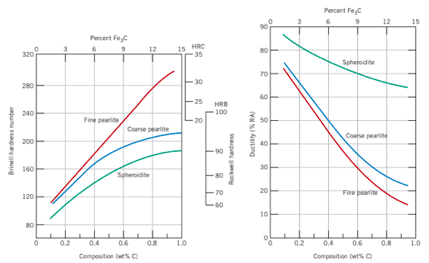
    - Martensite
      * 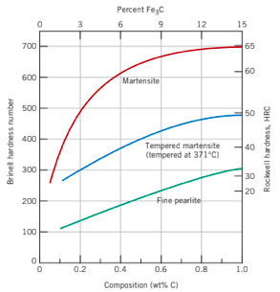
  + General heat treating
    - Change mechanical properties
      * Strength
      * Ductility
      * Toughness
    - Introduce or remove certain phases
      * Precipitation
      * Solutionizing
    - Change residual stresses
  + Steel heat treatment
    - Annealing
      * High temperature, slow cooling
    - Fll Anneal
      * Cool in the furnace as the furnace cools
    - Normalizing
      * Heating and air cooling
    - Quench and temper
      * Heat to austinite, then cool quickly to form martensite, then heat again lower and allow it to cool slowly
      * Tempering is heating and holding before you cool
  + Summary
    - Rapid cooling leads to
      * Very brittle
      * Very high strength
      * Martensite
    - Rapid cooling avoids other phases
    - Martensite is usually tempered to reduce stress

# Final Review

* + Application of Avrami equation
  + CCT diagram
    - Critical quenching rate
      * The minimum rate of queechning to produce a to martensitic structure
      * Cooling is to the left of the beginning of the pearlite transformation
    - Rate of cooling determines the microstructure
  + Steel microstructures
    - Pearlite vs spheroidite
      * Spheroidite
        + Ferrite with small cementite particles
        + When pearlite is heated to and left at temperature below the eutectoid temperature for a long period of time
        + Pearlite grains bunch together into globs
        + More stable than pearlite

Has a lower ferrite/cementite interface area and interface energy

That also makes it weaker

* + - * Coarse vs fine pearlite
        + Fine is pearlite has most area between ferrite and cementite (layers) and that blocks dislocation motion
        + More shear strength required to push a dislocation through the layers that are closer together
        + Coarse pearlite layers are further apart and a dislocation can push its way through easier
    - Martensite
      * Needles shaped martensite grains in austenite matrix
      * Hardest, strongest, and most brittle
        + Carbon won't dissolve
        + Too brittle to use

Not ductile at all

* + - * Most of the time, there is left over austenite
        + In use, this can turn into martensite and produce stress
    - Tempered martensite
      * Reheat, 600 degC ish
      * Small particles of cementite in a phase of ferrite
      * Similar to spheroidite microstructure but the cementit are much much smaller and more common
      * This means it is strong but also not as brittle as normal martensite
  + Creep
    - Occurs to materials placed in higher temperatures under static stresses
      * Like in turbines or steam generators
    - Time dependent deflection of materials
    - Only temperatures 0.4 times the melting temperature
    - Causes rupture
  + Fracture
    - Surfaces
      * Highly ductile necks to a point
      * Moderately ductile has cup and cone
        + 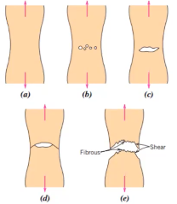
    - 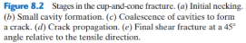
      * Brittle gives a clean break
        + Has v shaped chevrons pointing two the crack as you move away from the start of the crack
  + Fatigue
    - Multiple loadings can lead to a part failing below its predicted strength
    - Ways to lengthen fatigue life
      * Sharp corners are stress concentrators
        + Try adding fillets
      * Shot-peening
        + Creates a surface layer under compression
        + Reduced tensile strength on the surface
        + Preventing crack initiation
      * Polishing also helps
        + Removes flaws and hairline cracks
      * Carburizing and nitriding
        + Also puts surface layer in compression